**Food Ordering system**

Online food ordering is a process of ordering food from a local restaurant or food cooperative through a web page or app. Much like ordering consumer goods online, many of these allow customers to keep accounts with them in order to make frequent ordering convenient. A customer will search for a favorite restaurant, usually filtered via type of cuisine and choose from available items, and choose delivery or pick-up. Payment can be among others either by credit card or cash, with the restaurant returning a percentage to the online food company.

**Expected list of features**

Some expected list of features of the proposed website are listed below: ● A customer will search for a favourite restaurant,  
● Choose delivery or pick-up  
● Payment can be among others either by credit card or cash.

**Main Page**

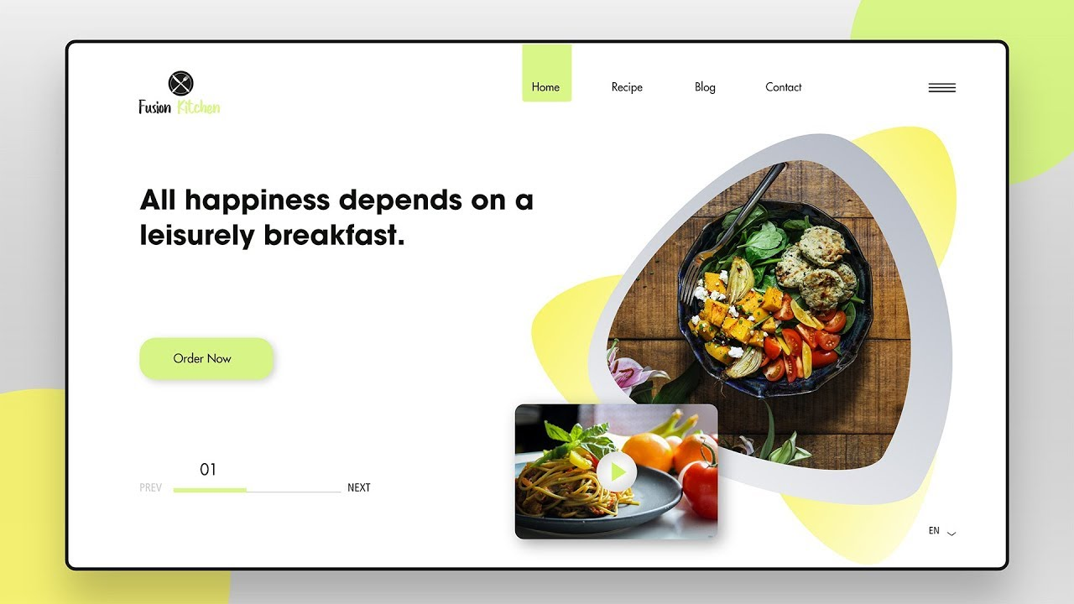

**Ordering Page**

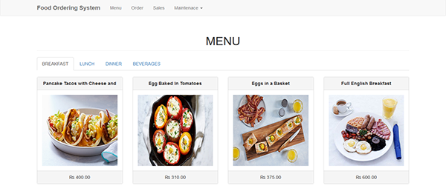

**Navigation Structure**

1. Home
2. Menu
3. About Us
4. Contact

**References**  
1. https://getbento.com/features/online-ordering/ 2. https://get.popmenu.com/  
3. https://www.jotform.com/food-ordering-system/